
Year 9 Science 2024

CAT 2 - Radioactivity Test

Name: _________________________________Form: ___________

Students are allowed to use a periodic table and scientific calculator.
The test will be completed under test conditions.

Reading Time: 10 minutes

Writing Time: 40 minutes

Total
/40
Percentage
%
Emerging | Working Towards | At the Standard | Above the Standard | Well Above the Standard

Section A - Multiple Choice (10 marks)
1. The nucleus of an atom is:  - made of protons and neutrons  - made of electrons and neutrons  - made of protons and electrons  - made of protons only | 2. What particle is released when an unstable isotope undergoes alpha radiation?  - a helium atom  - a helium nucleus  - an electron  - a photon of light
3. Rows of the periodic table are called:  - groups  - periods  - valences  - ions | 4. Which type of radiation releases an electron?  - alpha radiation  - beta radiation  - gamma radiation  - nuclear radiation
5. Use the periodic table to identify the correct statement about calcium.  - It is in period 2.  - It has an atomic number of 20 and a mass of 40.08  - Its electronic configuration is 2,8,6,2  - It has six electron shells | 6. Which of the following does not contribute to background radiation?  - mobile phones  - rocks  - decaying biological matter  - living creatures
7. A beta particle is:  - a proton  - a neutron  - an electron  - a particle | 8. Radioactive decay is described as spontaneous. In this context spontaneous means:  - nothing can influence the decay  - the decay is random  - the decay can be predicted  - the decay is exponential
9. In the nuclear reaction:  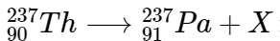  Particle X is:  - alpha  - beta  - gamma  - energy | 10. Iodine-131 reduces from 200 atoms to 25 atoms in 24 days. Half-life of Iodine-131 is:  - 24 days  - 16 days  - 12 days  - 8 days

Section B – Matching Terms (5 marks)
A | B
Radioactive decay | - a neutron is converted into a proton
Gamma rays | - conversion of radioactive isotope into its stable form
Alpha particle | - high speed electron
Beta particle | - high-energy electromagnetic rays
Beta decay | - a particle containing two protons and two neutrons

Section C – Short Answer Questions (25 marks)
Isotopes
Question 1
The two isotopes of carbon are shown below.
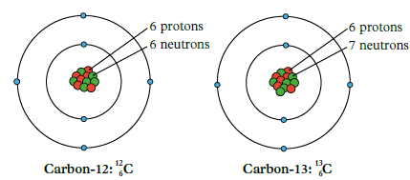

- What are isotopes? (2 marks)
_____________________________________________________________________________________________________________________________________________________________________________________________________________

- Using the information from the figure above, draw an isotope of carbon-14. (2 marks)

- Explain using the example of Carbon-12, how the ‘Atomic number’ is different from an ‘Atomic mass’?
(2 marks)
_______________________________________________________________________________________________________ ___________________________________________________________________________________________________________________________________________________________________________________________________________________________________________________________________________________________________________________________________________________________________________________________________________________________

- Explain why Carbon-12 atoms are more stable than Carbon-14 atoms. (2 marks)
__________________________________________________________________________________________________________________________________________________________________________________________________________________________________________________________________________________________________________________________________________________________________________________________________________________________________________________________________________________________________________________________________

Radioactivity
Question 2
a. Complete the following nuclear reactions. (2 marks)
1. | 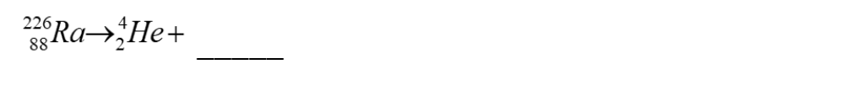
2.

b. Carbon-14 atoms are unstable; emitting beta particles as they decay. Write an equation to show this decay. (2 marks)

Question 3
Uranium-238 decays in a series of steps into Lead-206, Uranium-238 has a half-life of 4.5 billion years. The graph below shows the decay of Uranium-238 into Lead-206.
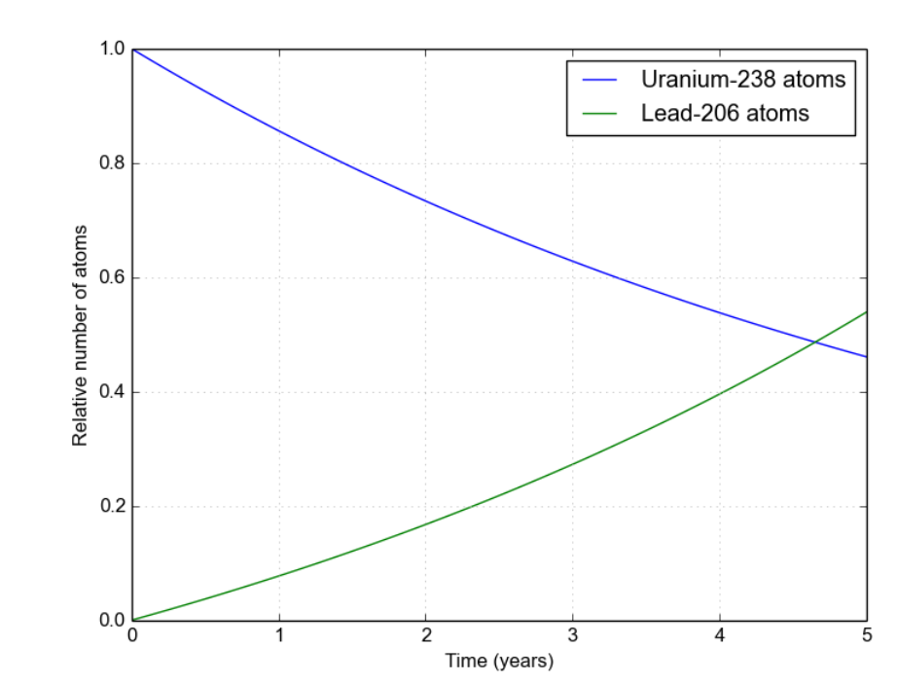
Referencing the graph, explain what is happening to the number of Lead-206 atoms over time. (2 marks)
______________________________________________________________________________________________________________________________________________________________________________________________________________________________________________________________________________________________________________________________________________________________________________________________________________________________________________________________________________________

Question 4
A Geiger counter is placed near a radioactive source. Different materials are placed between the radioactive source and the Geiger counter. The results of the tests are shown in the table below.
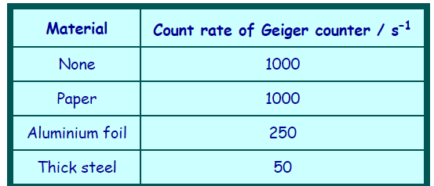
Using the results from the table, identify the 2 types of radiation the radioactive source emits. Explain how you know this. (4 marks)
__________________________________________________________________________________________________________________________________________________________________________________________________________________________________________________________________________________________________________________________________________________________________________________________________________________________________________________________________________________________________________________________________________________________________________________________________________________________________________________________________________________

Half-Life
Question 5
Protactinium has a half-life of 70 seconds. A sample of protactinium is prepared and monitored over a period of time. Calculate how many seconds it would take for the sample to drop to 25% of its original weight? (2 marks)
________________________________________________________________________________________________________________________________________________________________________________________________________________________________________________________________________________________________________________________________________________________________________________________

Question 6
A radioactive decay curve for strontium-90 is shown below.
What is the half-life of Strontium-90 from the graph. Provide evidence on the graph. (2 marks)
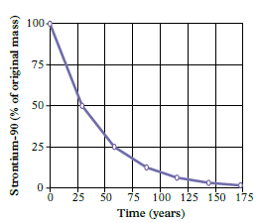

Question 7
The following graph shows the decay for Uranium-238 through to Uranium-234.
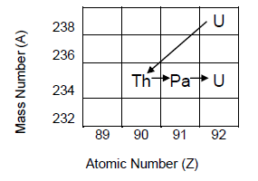
What type of decay particles are emitted during each of the decays listed (and shown in the diagram)? (3 Marks)

a) From Uranium-238 to Thorium-234 | Alpha OR Beta
b) From Thorium-234 to Protactinium-234 | Alpha OR Beta
c) From Protactinium-234 to Uranium-234 | Alpha OR Beta

End of Test


